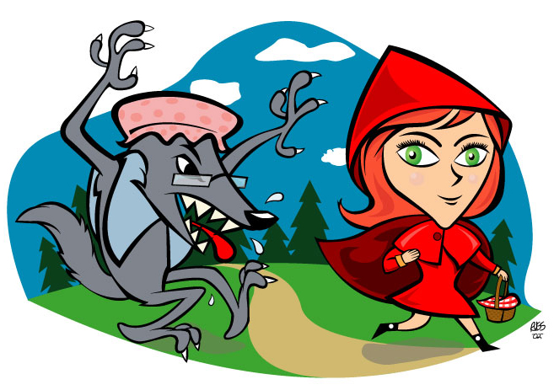
The Story of Little Red Riding Hood
“My name is Little Red Riding Hood.
I live near the woods". (nahe am Wald)
“Take the cookies to grandmother,” mother said. (cookies = Kekse)
“Poor grandmother is sick in bed.” (poor = arm, sick = krank)
"Mother told me not to stop in the woods (told me = sagte mir, not to stop = nicht stehen bleiben)
but, look at the flowers, pink, red and blue. (look at = anschauen, flowers = Blumen)
I love the flowers and the green trees too.”
“Hello" said the wolf to Little Red Riding Hood. (say – said = sagen – sagte)
The cookies you have smell very good.” (smell = riechen)
“The cookies are for Grandmother, not for you.”
“Have a nice day Mr. Wolf, Goodbye to you,”
The bad wolf is in the bed (bad = böse)
and poor Grandmother is in …the wolf. (poor = arm)
"Grandmother, what big eyes you have.” (eyes = Augen)
"So I can see you.” (see = sehen)
"Grandmother, what long ears you have" (long = lang, ears = Ohren)
"So I can hear you". (hear = hören)
"Grandmother, what a long nose you have". (nose = Nase)
"So I can smell the cookies!"
"Grandmother. What big teeth you have" (teeth = Zähne)
“So I can eat you………" (eat = essen)
The hunter saved grandmother and she was glad. (the hunter = der Jäger, saved = rettete, was glad = war glücklich)
Red Riding was happy but the wolf was sad. (sad = traurig)
The wolf was bad, but was Red Riding Hood good?
What can you say to a girl who stops in the woods? (Was sagt man zu einem Mädchen, dass im Wald stehen bleibt?)

© http://waves.galim.org.il/tales (Making Waves)

